Colour in Mood and Atmosphere Reflection

Introduction
To begin with, my initial idea was to create a series of photographs to effectively display mood and atmosphere in photography and establish a common theme or concept. Part ways through the project I realised that I could relate my work to nostalgia as my use of colour worked toward creating a very solemn and reflective series of photographs; but after some criticism, the concept was not quite clear and did not work as a discernible point of interest for my work. However, something that has been prevalent since the very beginning of the project is the use of colour in almost every one of my images, so I adjusted my sails and aimed to explore that aspect of my photography a little deeper. This then opened my project up to new techniques and the ability to identify my own style with techniques that would allow me to express mood visually with the use of colour. My early ideas also involved tapping into the cinematic sphere and looking at how some of the film industries greatest worked with mood and atmosphere when it came to composition and framing, this is when I saw how each director and visionary mostly relied on colour and tones within their productions to carry atmosphere. This is when I realised what my goal in the project should be.

Getting Started
As practice for this particular project, we had time to build skills and simply learn as much as we could in preparation. The most influential areas of practice came from the ‘Pathways’ photoshoot, which I still use for inspiration in my newer photoshoots. It is by far the most confident of all my outcomes, and seemingly, every photograph that came out of the shoot felt developed and individual. It was also the first time where I worked with Photoshop to edit and tweak aspects of my photographs in order to make them look more interesting and colourful. Each photograph has a significant amount of thought placed into each one, as I was having to think a lot about the formal elements; this way each composition had its own characteristics. This also went into how I approached each photograph; planning the compositional factors and looking at the placement of the camera to ensure I got the best viewpoint.
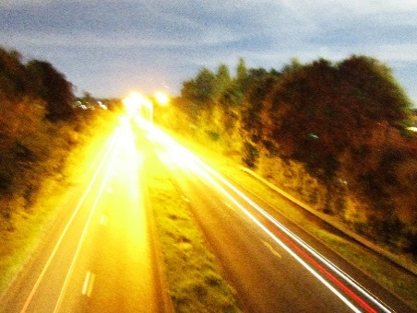
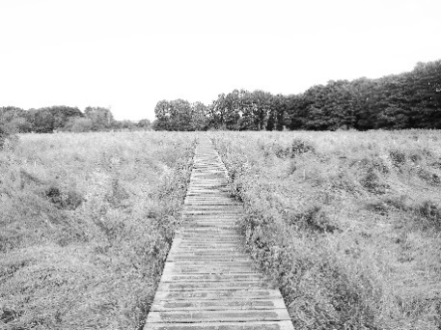
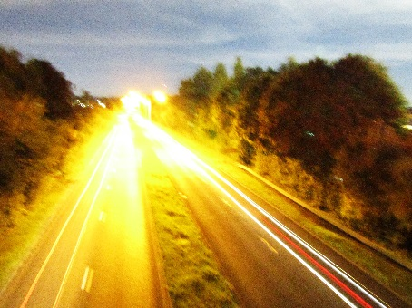
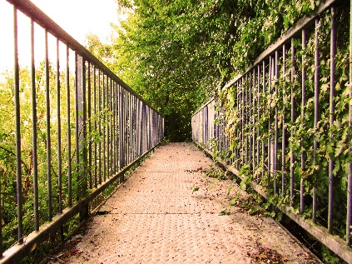

Photographs from my ‘Pathways’ shoot.
The main aspects I took from this particular practice shoot were how to appropriately brighten or perhaps darken an image in places where it was important. This helped create identifiable atmospheres throughout the images line-up. I learned simple steps such as experimenting with various aspects of colour within an image. These early developments and techniques I used to emphasise colour are the techniques I prominently used for this particular project. As it was the amongst the handful of earlier photoshoots, that were mainly used to help us understand what went into composing a photograph, it is probably the photoshoot that offered the most in terms of what I learned.
Additionally, one of the main things I took from the dense planning in earlier shoots was that planning had huge amounts of influence as to how the outcomes of the photoshoot can look. I translated these skills into having some initiative before a shoot took place, factoring in things such as location, weather, lighting and colour. Considering these variables allows me to adapt much better to my surroundings and therefore taking the best photographs.

Artist Research and experiments for a Solidified Idea
Originally, one of the more influential artists in my work, Brad Carlile was the main individual to inspire the colour and various techniques I brought forward and implemented into pretty much all of the experiments in my work. His use of colour has been something that has been repeated and emphasised heavily throughout my work. Additionally, another artist I always try to include some reference to with my use of compositions and expression through tone is Lucinda Chua. She has a keen sense of style usually featuring the use of people to add some expression to her darkened moods, which often compliment the use of sharpened retro colours coming from Carlile’s primary influences.
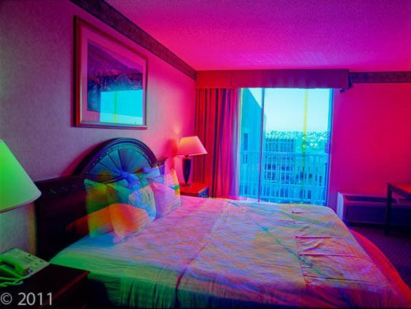
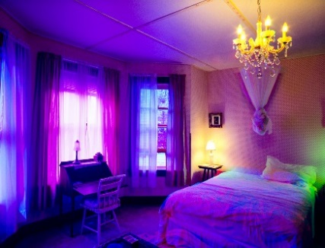
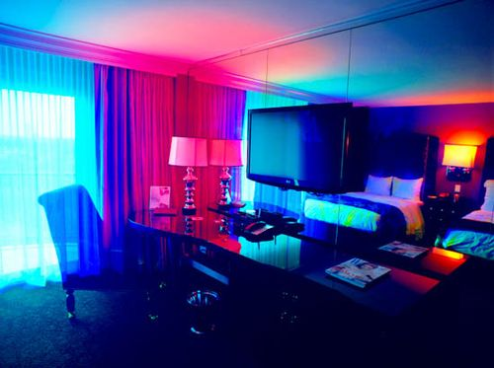

Photographs provided by Brad Carlile.
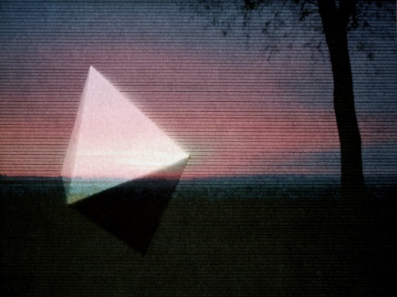
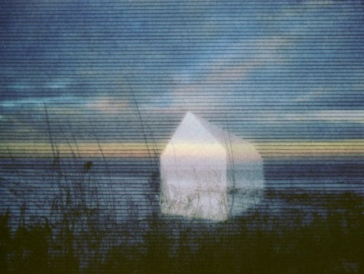
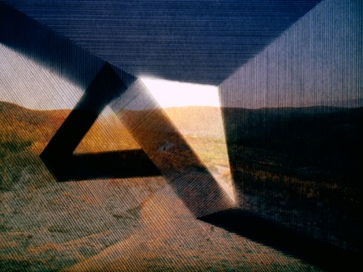
Additionally, the artist Popel Coumou has a very interesting style that really ties together the retro-coloured style I was aiming for with her distinct distortion techniques. At the beginning of the project I developed the style and integrated the style into my photography outcomes, unfortunately they lacked enough distinction to really make them a viable influence within my work. This was mostly because of the techniques I was using to bring out that distortion. However, after researching new and more intuitive options to recreate her techniques I was able to use her style effectively and bring her style back into my work.

Photographs provided by Popel Coumou.
As my work revolves heavily around the idea of colour being used to create effective mood and atmosphere, Brad Carlile is the main artist of my chosen few to be constantly influencing and inspiring me. The colour schemes and techniques he uses are vibrant, bursting and work really well to create a sombre and relaxing atmosphere. I have worked to bring in Chua’s style in order to add another element to my photographs. I would say the most effective example of the different styles working in tandem with each other would be an experiment of my sister sitting in purposefully selective lighting. Her upper torso is shrouded in darkened green colours while her lower half is exposed in bright yellow light revealing her stomach, showing a new sense of hope while she faded into obscurity. This was one of my most effective outcomes in terms of composition and expressiveness because of the symbolism and surreal nature of the light placements. However, the photograph does have its weaknesses, as there are a lot of unwanted shadows and darker tones sort of taking away from the focal points of the image. This is something I hope to improve when it comes to looking at future compositions and light placement.
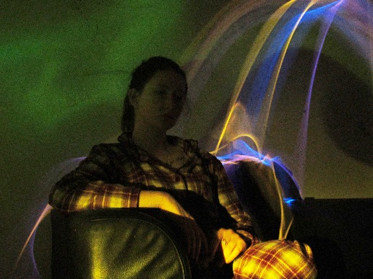
I had reached a point in the project where I had experiments that were becoming stale and too repetitive, and my vision of colour within my photography was becoming blurred and losing focus. Therefore, I knew a new influence would be important to creating a new sense of style and interesting technique. Quickly, I became interesting in an artist called Nicholas Goodden. He prominently uses colour, similar to the ones I was using, but he also places an effective motion blur effect to each of his photographs. This was the start of my fascination with motion blur as I began to experiment with different techniques and media in order to produce effective and interesting outcomes.
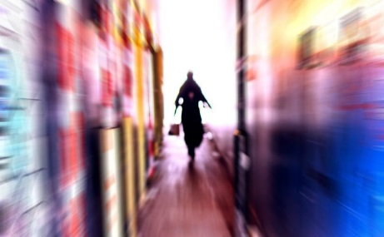
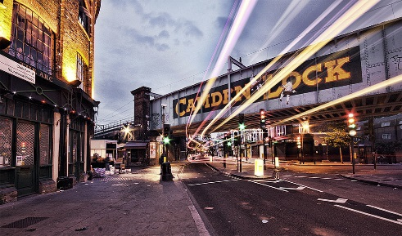
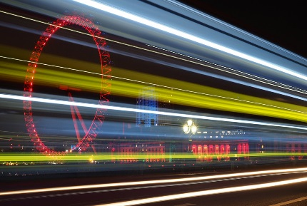

Final Experiments
For the final set of experiments, I wanted to simply combine each of my artist’s styles to create something visually interesting. I want people to see and notice a distinctive style emanating from my photographs. The use of colour, editing techniques and framing all work to serve one common purpose, and that is to create a potent atmosphere. I want the photographs to feel lucid and vibrant, while feeling solemn and brooding.
To get the best possible outcome I looked at each possible area to create my photographs. I looked at the best way to draw colour from my photographs and make it work within the image. I looked at different ways an image could be layered in order to fit each aspect of my artist’s visual variety. Working with digital editing worked best in the end, in order to best edit my photographs and make them seem to work in tandem much more cohesively. Brad Carlile was the most influential photographer that I took forward through my work and because of this, his style was very apparent through most of my images.
Towards the end of my project I felt like I had been doing the same thing, just with different takes and it began to show. Each of my photographs began to stagnate and I knew a change was necessary to make my photographs more appealing. That is why I brought Nicholas Goodden’s work into the project at such a late stage, and this opened up a wealth of opportunities to explore new techniques and find the best balance for my images. Bringing in a photographer like Goodden granted me to use various experiments to find the best way to replicate his visible style. Additionally, I managed to bring that string of development into my work as another inspiration.
The reason why I abandoned the Coumou technique earlier in the project is because I could not really get to grips with it at first and the outcomes were not very interesting or particularly obvious. Because the technique was not very subtle at first, so integrating it more into the image made it much more interesting and actually added something to the photographs. This made it much easier to bring back into my photography work and make the influence integral.

Final Piece evaluation and project reflection
Throughout the project I did not concern myself too much with finding a definitive concept that worked to display a particular message or point. I just focused on making the images work to make the viewer feel any type of mood. I think that the visual progression of my work and the clear improvements from photograph to photograph display the type of moods and atmosphere I attempted to create.
Another point I wanted to make before ending this project was how much my editing techniques and styles had come along over the course of the photography project. From the beginning, struggling with capturing some of my artists work, to then going on and finding the best possible way to replicate it and use new tools. One of the artists I was unhappy with was Coumou, as I never really felt like I captured her style (outside of the distortion and scan lines). Therefore, I revisited one of my older artist experiments and put my new techniques and skills to work. I was very happy with the clear distinction between the older experiment and the new experiment.
The most interesting factor by far about this project has been looking at how many other people have captured mood and atmosphere whether it be through film or photography or even art. Looking at different elements from many other people who have worked towards establishing mood and atmosphere in different media and looked at what made it interesting.
Through this project, I do not necessarily feel I have reached a style of my own, but that I have been able to explore new techniques discover more about the technical aspect that goes into each photograph. The distinguishing factor within each of my photographs has mostly been that I can seem to find a way to bring colour and mood to each photograph. From the outset of the project, I wanted to visualise palpable atmospheres and make each photograph unique to that mental image. I feel I have achieved that. I feel now that I can work more confidently; plan and approach each photoshoot with fresh ideas and a perceivable image.

Bibliography

ART2DAY (2012) Photoshop Examples [Online] Available from: http://www.art2day.co.uk/photoshop.html [Accessed: March 23rd 2016]

BRAD CARLILE (2003) My First Series: Refracted Movement [Online] Available from: http://www.bradcarlile.com/bio/technique.html [Accessed: March 23rd 2016]

CAMERON POLLOCK (2012) How to Fake Panning technique [Online] Available from: https://www.youtube.com/watch?v=fHQrZ-EmRHs [Accessed: October 20th 2016]

JAYMES GROSSMAN (2014) How to create motion blur using a DSLR camera [Online] Available from: https://www.youtube.com/watch?v=qrMYba-JmRU [Accessed: October 20th 2016]

KAZUO NAKAHARA (2016) Slow Shutter Art: Creating Surreal, Spinning Radial Blurs [Online] Available from: https://snapshot.canon-asia.com/article/en/slow-shutter-art-creating-surreal-spinning-radial-blurs [Accessed: November 21st 2016]

MYPORTAITHUB USER: PRAD (2014) 71 Coolest Examples of Smoke bomb Photography [Online] Available from: http://myportraithub.com/smoke-bomb-photography/ [Accessed: September 15th 2016]

NICHOLAS GOODDEN (2008) London Photography Gallery [Online] Available from: https://www.nicholasgooddenphotography.co.uk/best-london-photography [Accessed: October 17th 2016]

POPEL COUMOU (2006) Selected Work 2006-2013 [Online] Available from: http://www.popelcoumou.nl/photography/work [Accessed: March 23rd 2016]

YOUTUBE USER: STOCKHOLMCONTROVERSY (2012) Photoshop CS5 Tutorial: Television Scan Line Effect [Online] Available from: https://www.youtube.com/watch?v=ojnbk6MzksA [Accessed: November 2nd 2016]

Word Count - 1877

