**Analysing Barbara Kruger**

**Use these prompts to help you analyse the two images.**

* Describe the image.
* What message is the artist trying to convey?
* What does it make you think about? What is your opinion of the piece?
* What techniques does the artist use to make the image thought provoking and/or controversial?

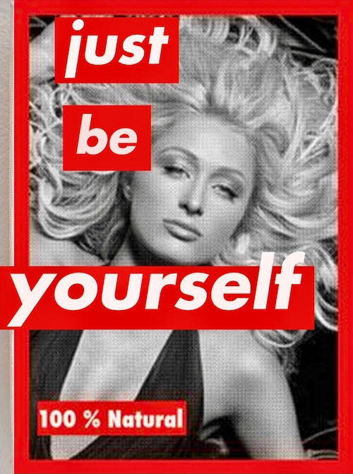

Finally, justify your own opinion about Kruger’s photography.