Close Up Photoshoot: Macro Photography
What am I learning? How to use the macro setting in a photoshoot.
What will I do? Take close up photos of nature in the style of Blossfeldt using the macro setting, informed by my photoshoot plan.
How will I be successful? Photos will be in focus, I will thoughtfully apply knowledge of the formal elements, specifically composition, and I will communicate with others effectively.

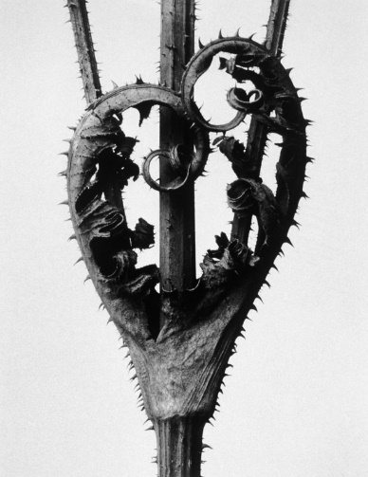
To work in the style of each photographer, you will need to:
Karl Blossfeldt
Close up of a section of nature

Macro setting

Fully in focus – show every little detail

Single object on a white background

Often captures pattern and/or symmetry

Object generally placed in the centre of the photo

Strong contrast created through lighting

***Aim to photograph some of the photos you planned on the planning sheet! This will make clear links between your planning and your outcomes, which will support you with the higher marks.***

Going for gold: How to push for higher marks!
Composition is key. Clear links between your own photographs and the composition used
by the photographers.
Use the formal elements to enhance your photos. Focus on capturing colour, tone and
shadows, line, pattern and texture.
Effective lighting will make a massive difference to your photos. Explore: spotlights with torch, soft diffused lighting, natural light by a window, flash on/off. Utilise shadows to enhance further!

REVIEW: Discuss, have you been successful this lesson? Do you know the answers to the following?
- What is the macro setting for?
- What is the success criteria for an effective macro photograph?
- What are the formal elements and how did you apply them to this photoshoot?
- What was the most effective composition for a macro photograph in this photoshoot?
- How did you photograph in the style of Blossfeldt ?
- What kind of lighting did you try? How did you utilise shadows to enhance your photos?

