Introduction
The theme I decided on for my project was issues. Issues itself is a very large and overwhelming topic so I broke it down into four categories; social, political, economic and environmental. This made me want to focus on social issues as I found it more of an interesting concept to photograph, in my opinion. I was not sure what social issue I specifically wanted to focus my project on so I experimented with different issues; abuse and drugs. This finalised my decision to focus my project on drugs to shed light on the increasing problem of narcotics within society and the growing normalisation and glamorisation of them in the media. I feel as though I have worked within the theme as I have looked at the holistic effects of drugs; looking more at the psychological effects of abusing drugs. For example, I have created photoshoot where each picture represents a different psychological effect of drug abuse, inspired by Christian Sampson’s photoshoot of mental disorders. Every story involving drugs is different; each person encounters different effects as a result of abusing drugs. I wanted to capture different effects in a negative way. Today’s media often glamorises the use of drugs, especially marijuana, so I wanted to go against that and show the reality of drugs.
Getting Started
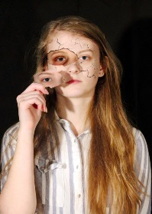
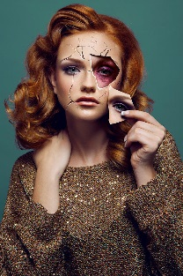
During the time in which I was undecided on what social issues, I wanted to focus my project on; I carried out some initial artist research into drugs and abuse. I was initially inspired by Helmo and Daryna Barykina. The photoshoot by Daryna Barykina was very eye-catching and meaningful as it was representing the abuse that is hidden. I wanted to experiment with this, as it was a very challenging way to edit images. However, after completing this image, I came to the realisation that abuse would be quite a narrow project for me to do. I thought that Helmo’s double exposure photoshoot would be an interesting way to photography drugs; putting the drugs layered over the person. However, I then decided to take inspiration from the capturing blue and red colours that were used in his work. This inspired the images of the drugs. When I had made the final decision to focus on drugs for my project, I started by shooting images of drugs themselves from the perspective of an individual that had consumed drugs. The images were intentionally blurred to represent the blurred vision that occurs when on drugs. I did this by layering two of the same images onto one another and slightly moving one layer to one side to create the blurred affect. I moved on from this because it was quite restrictive; there was not much I could develop with this. Therefore, I began more conceptual photography as this was visually more interesting and holds a more powerful message.
One of the photography skills I have learnt is the importance of lighting during a photoshoot. Many of my images came out too bright, this was due to a mixture of the wrong aperture and studio lights. This meant that I had too heavily edit some of my images in order to get the desired darker effect. Therefore, since this project, I have made sure to take pictures of just the background first so I can see whether the aperture or lighting needs to be changed. I did reshoot some of the images and change the aperture in order to make the images darker. In addition, I learnt Photoshop skills to add interest to my images. For example, the image shown inspired by Christian Sampson was representative of the confusion that an individual goes through whilst under the influence of drugs. I did this by using difference clouds.
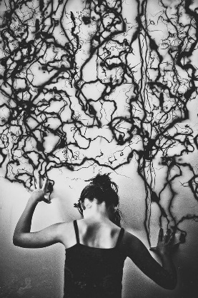
Artist Research and experiments for the final concept
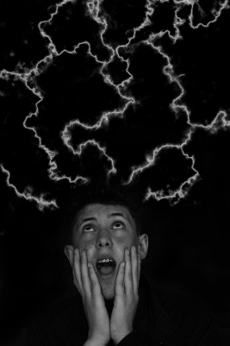
Christian Sampson inspired me to create images that went into more detail into how someone feels when he or she have consumed drugs. I began to create images that were representative of some possible psychological effects of abusing drugs. This photoshoot was inspired by the Christian Sampson shoot of the effects of living with a mental disorder. I especially liked how Christian Sampson broke down each element of mental disorders to allow audience who does not suffer from mental disorders to understand what it is like. The effects of mental disorders is quite similar to the side effects of drug abuse so it was a very inspirational photoshoot for my project. It was a very creative way to represent the effects of drug abuse.
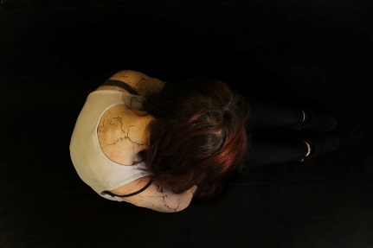
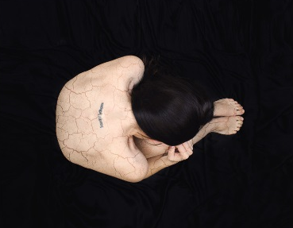
As well as Christian Sampson, my project was inspired by Katie Joy Crawford. She, also, did a photography project “My anxious heart” which is representative of her experience with anxiety. She used a creative way to express how it feels to live with anxiety to someone that does not suffer from it. The props that were used were very inspiring to my project as there were similar effects to drugs abuse. This inspired me to be more creative in capturing the effects of drug abuse, such as have clocks within the picture to represent time passing and the drug abuser not being aware and the cage to symbolise being trapped and isolated by the addiction.
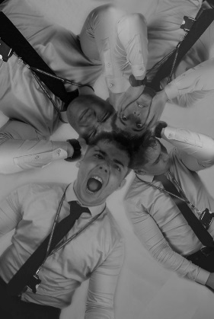
When combining elements from these artists, I took inspiration from the facial expressions in that were shown in Christian Sampson’s photography and the changing of positions in Katie Joy Crawford photography to generate different moods. In both work, both photographers used black backgrounds to ensure that the individual was the important element in the photos. Therefore, I, also, thought this was important to do so in my photoshoot too. I layered a range of images representing different moods to represent the constant mental changes that occurs whilst under the influence of drugs. The images show the mood swings, aggression, paranoia and fright that happens when an individual has taken drugs.
These experiments with the artist research of Christian Sampson and Katie Joy Crawford allowed me to realise that I wanted to look more at the mental and psychological impacts of using drugs. I found it a lot more interesting to research and create images for. In addition, the images that came out were more eye-catching and interesting from an audience perspective. It, also, helped as I study A-Level Psychology too so I could use my knowledge from that subject to make my photoshoot more real. Whilst studying depression, the main emotional characteristics involved included lower mood, low self-esteem and anger. Depression is a side effect of drug abuse so I wanted to capture these characteristics of depression within my pieces in order to have a more realistic look onto drug abuse. Depression can also be the cause of a drug addiction; some people decide to self-medicate to relieve the feelings of depression. Therefore, they use drugs to take themselves away from reality.
During the experiments inspired by artist research, I learnt that the background was important. When I completed the images inspired by Christian Sampson, I realised that I should have experimented with my background more. Christian Sampson shot his images against a white solid wall whereas I did mine against black cloth. I learnt that it was important to experiment with, both, black and white backgrounds whilst shooting in order to have more variation in my photography. In addition, I noticed that the individual in my work was ‘swallowed’ by the background sometimes, as it was too dark. Therefore, when I shot the images for combining the two artists, I experimented with both backgrounds in order to make my photoshoots more efficient.
Final Experiments
For my final experiments, I wanted to carry out some primary research into the effects that drugs have on adolescents. Whilst doing some research, I learnt that marijuana was more popular than cigarttes in high school students. Therefore, I thought it was important to shed light on this growing problem. I had an interview with a teacher that helps pupils with behavioural problems, family problems etc. I did this to get more insight into how adolscents get into drugs and why they do so. This conversation inspired me to create a photoshoot about how drug dealers use and manipulate young, vulnerable children in the drug world. One thing that the teacher said was “They [the drug dealers] have them [students] like a puppet on strings”, this imagery helped me to create an idea in my head. I wanted to use quotes in order to create a photoshoot. In addition, she said “drugs are an indentity”. These quotes were the subjects of my final experiments. I want the viewer to think about the problem that is growing in society and the importance of educating young people on drugs to convince young people that drugs are not desirable.
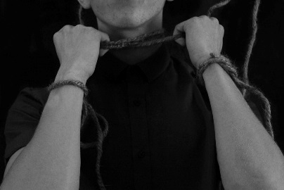
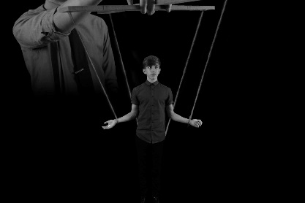
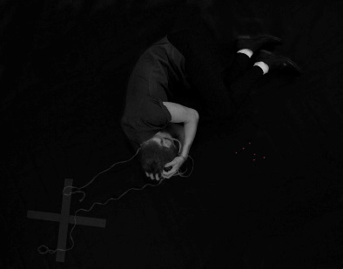
I created a series of six photos that was inspired by the interview. The series was heavily insired by the quote “They have them like a puppet on strings”. The series of photographs that I produced is intended to create a story of the journey that a lot of adolescents go through. The first image is intended to represent the change in perspective across the story. The first image of the individual shows him very happy and content with the fact he has received his drugs. He has not yet realised the manipulation and control of his drug dealer. The second shot of the individual encapsulates the realization that the dealer in now his puppeteer and is control him to do things he may not with, for example, making the dealer money by dealing the drugs in school. The final shot shows the individual looking very sad, his hand has moved down slightly to show that the want to drops the drugs and be free of this life but he cannot because his the drug dealer is still manipulating him.
The second photo in the image shows the individual trying to free himself from the control of the drug dealer, but he is unsuccessful. The third photo shows the drug dealer being in full control of the young adolescent. The 'dealer' is a lot bigger than the individual; to represent the power he has over the adolescent. The fourth image shows what the dealers manipulation can do; the adolescent is luring another vulnerable teenager in by dealer them drugs, possibly in schools, so the drug dealer now how two people to distribute his drugs and earn money for him. The fifth image illustrates the depressive thoughts that go through some adolescents head as a result of not being able to get out of the drug world. Here we see the individual trying to take their own life by using the rope from the marionette. I wanted to capture the reality of what has happened in some cases to contrast the glamorization of the drug culture in society. The last image represents the individual being dropped from control as they as no longer meeting the expectations of the drug dealer.
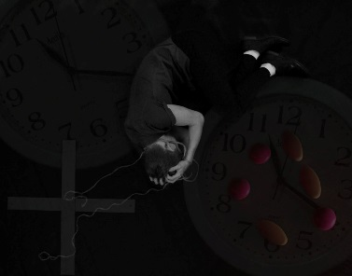
Although I thought that this series was one of the strongest outcomes, I felt as though something could be added in order to make these images more interesting and capturing. For this reason, I experimented with adding colour to the drugs to gravitate the audience’s eye to them slightly more. I gave the drugs within the images a slight pink colour to them so they would really pop compared to the black and white filter that was on the rest of the image. This was to emphasise the fact the series had the focus of drugs. However, I felt as though this was not striking enough, as the drugs were not big enough to be the focus. In addition, I experimented with positioning of the individual within the images to see if that would make the pieces more interesting. Although, I did not like the way this looked so I changed it back to the original format. As well as this, I experimented with props from Katie Joy Crawford’s work and added clocks to the background to lose some of the negative space. In addition, this was to signify the possible side effects of drugs. However, it made the image look too busy and took the attention away from the individual and the drugs.
Final Piece
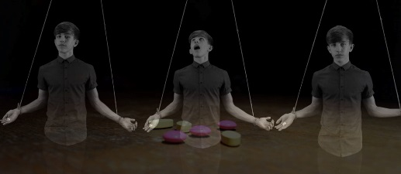
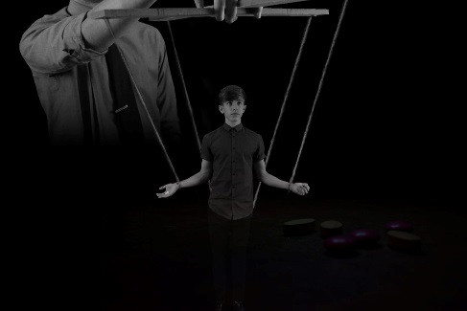
The experiments that I conducted made it evident that I needed to add something to my series of photographs to make them more interesting and appealing to the eye. The initial series had slightly too much negative space so something needed to be added to further the photos. To give me some inspiration of what to add, I looked through my past work and found the images of drugs that I produced. Therefore, I decided to experiment by adding pictures of ‘drugs’ in the negative space with a low opacity. As the rest of the image was black and white, the pink and yellow colours really shone through. This added a lot more to my piece and made it clear that the story was regarding drugs. I took images of medication in a dark room and used the torch from my phone to create different lightings. My favourite type of lighting was a spotlight effect on the ‘drugs’. This created a lot of mood and depth to the images. I then picked out which images best fit the series of photos and layered them onto the series of images in Photoshop. I lowered the opacity and blended the images together to make them seamless. I believe this made the pieces a lot stronger as it emphasised that the story was regarding the effects of drugs. In addition, it added fluidity to my project as a whole by linking back to old experiments. Overall, the thing that I am most happy with is that my series tells the story of many adolescents experiences with drugs. As a result of in-depth research, the series came out very realistic and true to the occurrences of some people’s everyday life.

Bibliography
- Time To Change. (2017). Types of problems. [online] Available at: https://www.time-to-change.org.uk/about-mental-health/types-problems [Accessed 7 Nov. 2017].

- Beauty will save. (2017). Red and blue photography by Helmo - Beauty will save. [online] Available at: http://viola.bz/red-and-blue-photography-by-helmo/ [Accessed 7 Nov. 2017].

- DARYNABARYKINA.COM. (2017). Bruised Behind The Masc. [online] Available at: http://darynabarykina.com/portfolio/bruised-behind-the-mask/ [Accessed 7 Nov. 2017].

- PHLEARN (2014). Create an Amazing Cracked Skin Effect in Photoshop (Part 1). [video] Available at: https://www.youtube.com/watch?v=yeC-Dqg6DKc [Accessed 7 Nov. 2017].

- PHLEARN (2014). Create an Amazing Cracked Skin Effect in Photoshop (Part 2). [video] Available at: https://www.youtube.com/watch?v=5uOzIxbsxdA [Accessed 7 Nov. 2017].

- Sekulic, N. (2017). How to create smoke in Photoshop. [video] Available at: https://www.youtube.com/watch?v=FIBXXglbYtQ [Accessed 7 Nov. 2017].

- Recovergateway.org. (2017). Effects of Drug Abuse and Addiction | Gateway Treatment Centers. [online] Available at: https://recovergateway.org/substance-abuse-resources/drug-addiction-effects/ [Accessed 7 Nov. 2017].

- HuffPost Canada. (2017). Photographer Captures The Haunting Reality Of What Mental Disorders Look Like. [online] Available at: http://www.huffingtonpost.ca/2016/01/27/living-with-mental-disorders_n_9089996.html [Accessed 7 Nov. 2017].

- katie joy crawford. (2017). my anxious heart. [online] Available at: https://katiejoycrawford.wordpress.com/2015/05/12/my-anxious-heart/ [Accessed 7 Nov. 2017].

- Easy to Read Drug Facts. (2017). Heroin addiction: "I needed the drug just to get by.". [online] Available at: https://easyread.drugabuse.gov/content/heroin-addiction-i-needed-drug-just-get [Accessed 7 Nov. 2017].

- Dosomething.org. (2017). 11 Facts About Teens And Drug Use | DoSomething.org | Volunteer for Social Change. [online] Available at: https://www.dosomething.org/us/facts/11-facts-about-teens-and-drug-use [Accessed 7 Nov. 2017].

