Close up: Macro Photoshoot Planning page

For the photoshoot next lesson, I will be taking photos of different natural objects. These are my composition plans for each natural object, drawn by hand.
- Sheep Skull: Draw 3+ rectangles over sections of the skull to demonstrate potential close up compositions that you could photograph.
- Driftwood Log: Draw 3 boxes that would be interesting to photograph, varying landscape and portrait.
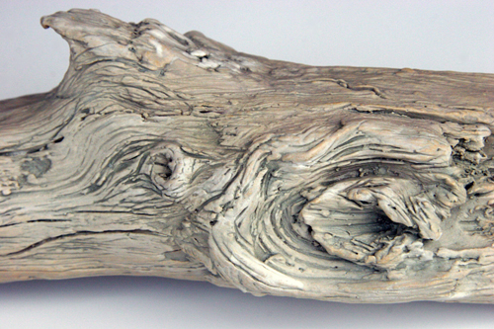
- If this was your selection of objects to choose from, which shells would you choose and which sections of each one would you photograph? Draw the SECTIONS below in the boxes, thinking about composition. Label which shell is which by drawing an arrow from the picture to your drawing.
